

JOGU

Software Requirements Specification

Version 1.2

December 14, 2016

José Esteves
Ricardo Malafaya

Prepared for ERMS - Requirements Engineering and Software Modeling, FEUP, 2016


Revision History
Date | Description |  | Author | Comments
2016-11-10 |  | Iteration 0 - First draft | J&R | Version 1.1
2016-11-11 |  | Iteration 1 - PO Modifications | J&R | Version 1.2
2016-12-07 |  | Iteration 2 | J&R | Version 1.3
2016-12-14 |  | Final – Structure Reformulated | J&R | Version 2.0

Document Approval #TBD
The following Software Requirements Specification has been accepted and approved by the following:
Signature | Printed Name | Title | Date
Gustavo | Gustavo | PO | 2016-11-09
Gustavo | Gustavo | PO | 2016-11-11
Gustavo | Gustavo | PO | 2016-12-14

Table of Contents

Revision History ii
Document Approval #TBD ii
1. Introduction 1
1.1 Purpose 1
1.2 Scope 1
1.2.1 Goals 1
1.2.2 Stakeholders 1
1.3 Definitions, Acronyms, and Abbreviations 1
1.4 References 2
1.5 Overview 2
2. General Description#TBD 3
2.1 Product Perspective#TBD 3
2.2 Product Functions#TBD 4
2.2.1 User Login Use Case 4
2.2.2 User Manages Groups Use Case 5
2.2.3 User Manages Events Use Case 7
2.2.4 User Manages Stats Use Case 9
2.3 User Characteristics#TBD 11
2.4 General Constraints#TBD 11
2.5 Assumptions and Dependencies#TBD 12
3. Specific Requirements#TBD 12
3.1 External Interface Requirements#TBD 12
3.1.1 User Interfaces#TBD 12
3.1.2 Hardware Interfaces#TBD 12
3.1.3 Software Interfaces#TBD 12
3.1.4 Communications Interfaces#TBD 12
3.2 Functional Requirements#TBD 12
3.4 Classes / Objects 17
3.4.1 User Entity 17
3.4.2 Group Entity 18
3.4.3 UserType Entity 18
3.4.4 Event Entity 18
3.4.5 Team Entity 18
3.4.6 Stat Entity 18
3.5 Non-Functional Requirements#TBD 19
3.5.1 Performance#TBD 19
3.5.2 Reliability#TBD 19
3.5.3 Availability#TBD 19
3.5.4 Security#TBD 19
3.5.5 Maintainability#TBD 19
3.5.6 Portability#TBD 19
3.6 Inverse Requirements#TBD 19
3.7 Design Constraints#TBD 19
3.8 Logical Database Requirements#TBD 19
3.9 Other Requirements#TBD 19
A. Appendices#TBD 19
A.1 Activity Diagram#TBD 20
A.2 Class Diagram#TBD 20
A.3 State Diagram#TBD 20
A.4 Dependency Matrix#TBD 20
A.5 Requirements and their attributes#TBD 20

1. Introduction

1.1 Purpose
The purpose of this document is to present a detailed description of the Web Social Football amateur system. It will explain the purpose and features of the system, the interfaces of the system, what the system will do, the constraints under which it must operate and how the system will react to external stimuli. This document is intended for both the stakeholders and the developers of the system.
The software JOGU is a mobile platform where football amateur players can share experiences. The users of this application can create football games, called events, and invite other users to join and create a game. This app permit to share live goals, attendance and results of each event. Each player can also check past games, goals and statistics.

1.2 Scope
This software system will be a mobile platform where football amateur players can share experiences called SOGU. The system will be design the facilitate the management of large groups of friends that have scheduled game events.
The users of this application can create football games, called events, and invite other users to join and create a game. More specifically, this system is designed to allow the user to create and share events with a group of friends and share live goals, attendance and results of each event. Each user will be able to check the score of past events and consult statistics about them self’s.

1.2.1 Goals
This software is a platform of share experience of the amateur football players. The user can create events. To each event, other users can be invited and attend. After the users confirm that they will attend the event, the teams are made. All the participants of the event can share stats of the event. The creator of the event is set as an administrator of that event and can overwrite any stat publish by the attendees. The administrator can attribute administrator’s permissions to other users on the event.
Each user can connect to application through login and access their own stats.
This application is targeting mobile devices (Android and IOS). To publish stats the application needs access to internet but also will permit to consult the stats offline.
In summary, the goals are:
- User Invites Friends to Events
- User Creates Game Events
- User Publishes Game Stats

1.2.2 Stakeholders
The relevant stakeholder of this application are the product owner, the group of developers and the people that will use the app, both those who interact with its features and users as well as the users who are just viewing and exploring the displayed information..

1.3 Definitions, Acronyms, and Abbreviations
Term | Definition
User | Any amateur football player that use the application to create events, attend to events or check stats.
Event | Is a meeting created by the users which users can attend with the information about the time and the place where the amateur football game will be taking place.
Administrator | In case of incorrect stats, the administrator is the user with the permission to alter the stats publish by the users.
Super Administrator | Person of developing team charged to intervene in case of failure.
Group | A list of users. A group can be associated to several events.
Stats | Published information that can be goals, attendance or final score of the event
Team | At event, the participants are divided in to groups.
Invitation | An invitation send by the creator of the event. The users can accept this invitation
Statistics | Information that the user can access about the events, goals, results and attendance of past events.

1.4 References
IEEE. IEEE Std 830-1998 IEEE Recommended Practice for Software Requirements Specifications. IEEE Computer Society, 1998.

1.5 Overview
The next chapters, the Overall Description section, of this document gives an overview of the functionality of the product. It describes the informal requirements and is used to establish a context for the technical requirements specification in the next chapter.
The third chapter, Requirements Specification section, of this document is written primarily for the developers and describes in technical terms the details of the functionality of the product.
Both sections of the document describe the same software product in its entirety, but are intended for different audiences and thus use different language.
This table represent the relations between goals (section 1.3), user cases (section 2.2) and requirements (section 3.2):
ID | Goals | ID | Use Cases |  | Requirements
 |  | UC0 | User Login | R0.1 | User Login
 |  | UC0 | User Login | R0.2 | User Register
G1 | User Invites Friends to Events | UC1.1 | User Manages Group | R1.1 | User Creates Groups
 |  |  |  | R1.2 | User Checks Group
 |  |  |  | R1.3 | Admin Edits Group
G1 | User Invites Friends to Events | UC1.2 | User Accepts Invitation | R1.4 | User Accepts Invitation
G1 | User Invites Friends to Events | UC1.3 | Admin Adds Event to Group | R1.5 | Admin Adds Event to Group
G2 | User Creates Game Events | UC2.1 | User Manages Event | R2.1 | User Creates Event
 |  |  |  | R2.2 | User Checks Event
 |  |  |  | R2.3 | Admin Edit Event
G3 | User Publishes Game Stats | UC3.1 | User Adds Stat to Event | R3.1 | User Adds Stat to Event
G3 | User Publishes Game Stats | UC3.2 | User Manages Stat | R3.2 | User Check Stat
 |  |  |  | R3.3 | Admin Edits Stat

2. General Description#TBD
This section will give an overview of the whole system. The system will be explained in its context to show how the system interacts with other systems and introduce the basic functionality of it. It will also describe what type of stakeholders that will use the system and what functionality is available for each type. At last, the constraints and assumptions for the system will be presented.

2.1 Product Perspective#TBD
This system will consist of two parts: one mobile application and one web portal. The mobile application will be used to find restaurants and view information about them while the web portal will be used for managing the information about the restaurants and the system as a whole.
The mobile application will need to communicate to a GPS application within the mobile phone, which in turn communicates with a physical GPS device to find the location of the user, see Figure 1. The GPS will provide the mobile application with locations of both the user and the restaurants and the distance between them, but it will also provide maps and the functionality to display the application’s data on the map. The functionality provided by the GPS will be embedded into the application in order for the user to be able to use the functions in the application in a seamlessly manner.
Since this is a data-centric product it will need somewhere to store the data. For that, a database will be used. Both the mobile application and web portal will communicate with the database, however in slightly different ways. The mobile application will only use the database to get data while the web portal will also add and modify data. All of the database communication will go over the Internet.
The mobile application has some restrictions about the resource allocation. To avoid problems with overloading the operating system the application is only allowed to use 20 megabytes of memory while running the application. The maximum amount of hard drive space is also 20 megabytes.

2.2 Product Functions#TBD
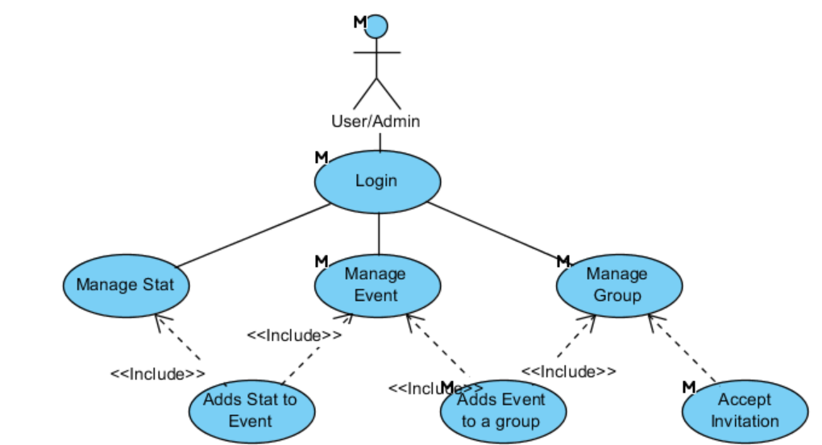
Figure 1 - System Environment
This subsection of the SRS should provide a summary of the functions that the software will perform.

2.2.1 User Login Use Case

Use Case: UC0 - User Login
Diagram:
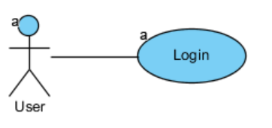
Brief Description
The user can login into the system with email and password. If the user is not registered in system, he can register a new account.

Initial Step-By-Step Description
The first interaction between the user and the application. The login will appear on the launch of the App.

- The user selects login method: email and password or Google account or Facebook account.
- The user inserts credentials.
- After confirmation, the system will show the main app window.

Xref:
Goals: G1 + G2
Requirements: R0.1 + R0.2
Mock: M0

2.2.2 User Manages Groups Use Case

Use case: UC1.1 - User Manages Group
Diagram:
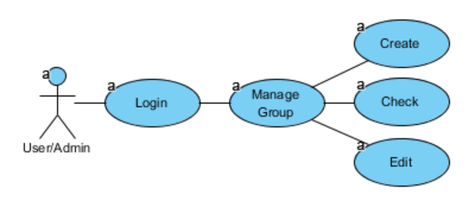
Brief Description
The user creates a group by adding users by inputting an email. Every user in the group can consult but only the user with administrator permissions can edit it.

Initial Step-By-Step Description
Before user create a group, has to be login on system.

- The user on “Main Page” can select a group on the group’s list or select the add sign to create a new one.
- The system redirects to the “Group page”.
- If the user is admin, he can select the group name to alters it, can add admin permissions to users or select the add sign to send invites to other users.
- All the users that already accept an invite will show on the list.

Xref:
Goals: G1
Requirements: R1.1 + R1.2 + R1.3
Mock: M1 + M2

Use case: UC1.2 - User Accepts Invitation
Diagram:
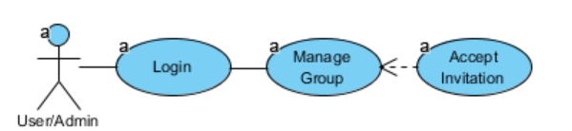
Brief Description
The user can receive invitations to enter in other group

Initial Step-By-Step Description
As soon as the author of the user add a friend user to a group. This user will receive an invitation by email.

- The user selects the link send by email.
- The system automatically adds the user to the group of the invitation.

Xref:
Goals: G1
Requirements: R1.4

Use case: UC1.3 - Admin Adds Event to Group
Diagram:
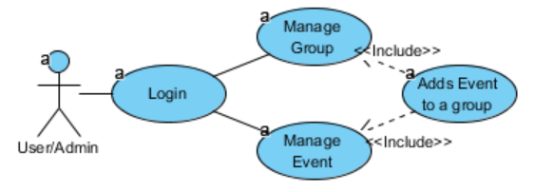
Brief Description
After the group is made, the administrator can add new events.

Initial Step-By-Step Description

- From the “Main Page” the user selects the group that wants to add an Event.
- The System will show the “Group Page”
- The user selects option “Add Event”
- The system list all the events without group and an option to create a new one.

Xref:
Goals: G1 + G2
Requirements: R1.5
Mock: M1

Scenario: S1 - User Invites Friends to Events #TBD#
Diagram:
Brief Description
The user can login into the system with email and password. If the user is not registered in system, he can register a new account.

Initial Step-By-Step Description
The first interaction between the user and the application. The login will appear on the launch of the App.

- The user selects login method: email and password or Google account or Facebook account.
- The user inserts credentials.
- After confirmation, the system will show the main app window.

Xref:
Goals: G1 + G2
Requirements: R0.1 + R0.2
Mock: M1

2.2.3 User Manages Events Use Case

Use case: UC2.1 - User Manages Event
Diagram:
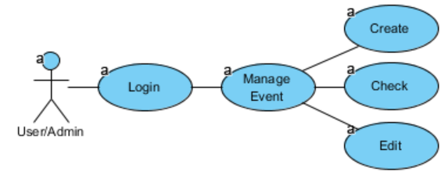
Brief Description
The user creates an event. Every event has an associated group. Each user of the associated group, can check the event. Only the users with administrator permissions can edit the event.

Initial Step-By-Step Description
Before user create an event, has to be login on system.

- From the “Main Page”, the user can select an event on the event’s list and system redirects to the “Event page” that will show the date, location, teams and final score of the event.
- If the user is admin, he can:
  - Select modify the date, location and team dispositions of the event.
  - Create a new event from the Group page.

Xref:
Goals: G2
Requirements: R2.1 + R2.2 + R2.3
Mock: M3

Scenario: S2 - User Creates Game Events #TBD#
Diagram:
Brief Description
The user can login into the system with email and password. If the user is not registered in system, he can register a new account.

Initial Step-By-Step Description
The first interaction between the user and the application. The login will appear on the launch of the App.

- The user selects login method: email and password or Google account or Facebook account.
- The user inserts credentials.
- After confirmation, the system will show the main app window.

Xref:
Goals: G1 + G2
Requirements: R0.1 + R0.2
Mock: M1

2.2.4 User Manages Stats Use Case

Use case: UC3.1 - User Adds Stat to Event
Diagram:
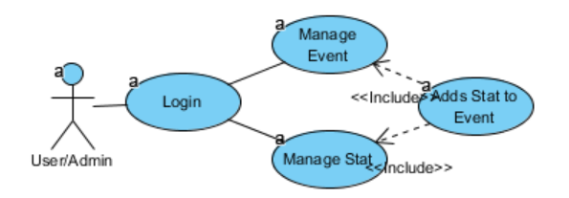
Brief Description
After the event is made, the users can add stats to it. The users can access the event and add stats to it.

Initial Step-By-Step Description

- From the “Main Page” the user selects the event that wants to add an Stat.
- The System will show the “Event Page”
- The user selects option “Add Stat”
- The system will redirect to the “Stat Page”.
- The user enters the author of the stats and the stat info.

Xref:
Goals: G1 + G2
Requirements: R3.1
Mock: M3

Use case: UC3.2 - User Manages Stat
Diagram:
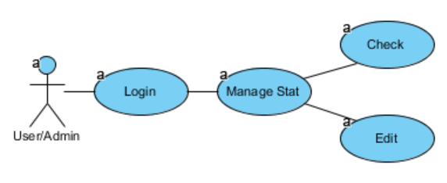
Brief Description
The user can check the stats associated to him or the stats associated with an event. If the user has administrator permissions on the group associated with the event that contain the stat, then he can edit it.

Initial Step-By-Step Description
Before user manage a stat, has to be login on system.

- The user selects the Stats from the “Main Page”
- The system will show the list of all the stats which the user is involved.
- If the user has admin permission over the stats, he can change it by clicking on it.

Alternative

- The user selects the Event from the “Main Page”
- The system will show the “Event Page”, and the list of all the stats related to that Event.
- If the user has admin permission over the stats, he can change it by clicking on it.

Xref:
Goals: G1 + G2
Requirements: R3.2 + R3.3
Mock: M4 + M3

Scenario: S3 - Publishes Game Stats #TBD#
Diagram:
Brief Description
The user can login into the system with email and password. If the user is not registered in system, he can register a new account.

Initial Step-By-Step Description
The first interaction between the user and the application. The login will appear on the launch of the App.

- The user selects login method: email and password or Google account or Facebook account.
- The user inserts credentials.
- After confirmation, the system will show the main app window.

Xref:
Goals: G1 + G2
Requirements: R0.1 + R0.2
Mock: M1

2.3 User Characteristics#TBD
With the mobile application, the users will be able to search for restaurants. The result will be based on the criteria the user inputs. There are several search criteria and it will be possible for the administrator of the system to manage the options for those criteria that have that.
The result of the search will be viewed either in a list view or in a map view, depending on what criteria included in the search. The list view will have one list item for each restaurant matching the search criteria and show a small part of the restaurant information so the user can identify the restaurant. The map view will show each restaurant location as a pin on the map as well as the user’s own location. In both views the users will be able to either select a restaurant as target destination or get information how to get there, or view the information of a specific restaurant.
The web portal will provide functionality to manage the system and the restaurant information. It will also provide information about the system, for example show when there is a new update.

2.4 General Constraints#TBD
The mobile application is constrained by the system interface to the GPS navigation system within the mobile phone. Since there are multiple system and multiple GPS manufacturers, the interface will most likely not be the same for every one of them. Also, there may be a difference between what navigation features each of them provide.
The Internet connection is also a constraint for the application. Since the application fetches data from the database over the Internet, it is crucial that there is an Internet connection for the application to function.
Both the web portal and the mobile application will be constrained by the capacity of the database. Since the database is shared between both application it may be forced to queue incoming requests and therefor increase the time it takes to fetch data.

2.5 Assumptions and Dependencies#TBD
One assumption about the product is that it will always be used on mobile phones that have enough performance. If the phone does not have enough hardware resources available for the application, for example the users might have allocated them with other applications, there may be scenarios where the application does not work as intended or even at all.
Another assumption is that the GPS components in all phones work in the same way. If the phones have different interfaces to the GPS, the application need to be specifically adjusted to each interface and that would mean the integration with the GPS would have different requirements than what is stated in this specification

3. Specific Requirements#TBD

3.1 External Interface Requirements#TBD

3.1.1 User Interfaces#TBD

3.1.2 Hardware Interfaces#TBD

3.1.3 Software Interfaces#TBD

3.1.4 Communications Interfaces#TBD

3.2 Functional Requirements#TBD
This section describes specific features of the software project. If desired, some requirements may be specified in the use-case format and listed in the Use Cases Section.~

3.2.1 R0.1 - User Login
Use Case Name | UC0 - User Login
XRef | Section 2.2.1, UC0 - User Login  Mock M0
Trigger | The user opens application
Precondition | The user has not yet logon on application
Basic Path | - The user opens the application  - The system displays login by email, Google or Facebook.  - The user has to choose the login type and enter the credentials.  - The system will check if the credentials are correct  - The main window of the app is shown
Alternative Paths | In step 2., if user already logon on app go to 5.
Postcondition | User enters main page
Exception Paths | If credentials are not correct, shows a error message.
Other | None

3.2.2 R0.2 - User Registers
Use Case Name | UC0 - User Login
XRef | Section 2.2.1, UC0 - User Login  Mock M0
Trigger | The user opens application
Precondition | The user has not yet logon on application
Basic Path | - The user opens the application  - The system displays login by email, Google or Facebook.  - The user enters the credentials and selects Register.  - The system will send a verification email to user.  - The system shows a message to the user verify the email.  - System hangs until confirmation of email and proceeds.  - System verify invitations (See 3.2.6 R1.4 - User Accepts Invitation)
Alternative Paths | None.
Postcondition | The database has been updated.
Exception Paths | In case of no internet, the system message user that cannot proceed without internet
Other | None

3.2.3 R1.1 - User Creates Group
Use Case Name | UC1.1 - User Manages Group
XRef | Section 2.2.2, UC1.1 - User Manages Group  Mock M1, M2
Trigger | The user selects the option “Create a Group” from Main page
Precondition | The user has already logon on system
Basic Path | - The user selects the users to add (from past events) or inputs the other users email.  - The system verifies information and shows the group window
Alternative Paths | None.
Postcondition | The database has been updated.
Exception Paths | In case of no internet, the system message user that cannot
Other | None

3.2.4 R1.2 - User Checks Group
Use Case Name | UC1.1 - User Manages Group
XRef | Section 2.2.2, UC1.1 - User Manages Group  Mock M1, M2
Trigger | The user selects the group from Main page or select the associated group from the event page.
Precondition | The user has already logon on system
Basic Path | - The system shows all the users and permission of that group.
Alternative Paths | None.
Postcondition | The users that were invited but not accepted the invitation yet will appear in grey.
Exception Paths | None.
Other | None.

3.2.5 R1.3 - Admin Edits Group
Use Case Name | UC1.1 - User Manages Group
XRef | Section 2.2.2, UC1.1 - User Manages Group  Mock M1, M2
Trigger | The user selects the group from Main page
Precondition | The user has to have administrator permissions in the group.
Basic Path | - The user select a user from the group and can:  - Add Admin permissions  - Remove user
Alternative Paths | The user can still add new users (see R1.1)
Postcondition | The database has been updated.
Exception Paths | In case of no internet, the system message user that cannot
Other | None

3.2.6 R1.4 - User Accepts Invitation
Use Case Name | UC1.2 - User Accepts Invitation
XRef | Section 2.2.2, UC1.2 - User Accepts Invitation  Mock M2
Trigger | “Other” user add “this” user to a group
Precondition | The user has to be invited to enter a group and user must have an email.
Basic Path | - User receives an email with an invitation link  - When user access the link, the system adds the user to the group automatically without user open the app.
Alternative Paths | If there the user had not created an account:  - User receives an email with an invitation link  - When user access the link, the system adds the email user to group.  When the user Register the email, the system checks if the email is already associated with any Group.
Postcondition | The database has been updated.
Exception Paths | In case of no internet, the system message user that cannot
Other | None.

3.2.7 R1.5 - Admin Adds Event to Group
Use Case Name | UC1.3 - Admin Adds Event to Group
XRef | Section 2.2.2, UC1.3 - Admin Adds Event to Group  Mock M1, M2, M3
Trigger | The user selects option “Add Event” from group page.
Precondition | The user has already logon on system
Basic Path | - The user selects option “Add Event” from group page  - The system show list of events associated with group and an option to create a new one.  - The user can:  - Select an already created event to repeat  - Create a new event (see R2.1 - User Creates Event)  - The system returns back from the Group page with the new event listed.
Alternative Paths | In step 3, user can go back.
Postcondition | The database has been updated.
Exception Paths | In case of no internet, the system message user that cannot
Other | None.

3.2.8 R2.1 - User Creates Event
Use Case Name | UC2.1 - User Manages Event
XRef | Section 2.2.3, UC2.1 - User Manages Event  Mock M2, M3
Trigger | The user selects the option “Add an Event” from Group page (see R1.5 - Admin Adds Event to Group)
Precondition | The group has to already be created.
Basic Path | - The system shows the event page.  - The users enter the Event info (location, date, etc).  - The system returns back from the Group page with the new event listed.
Alternative Paths | In step 1. and 2., user can go back.
Postcondition | The database has been updated.
Exception Paths | In case of no internet, the system message user that cannot
Other | None.

3.2.9 R2.2 - User Checks Event
Use Case Name | UC2.1 - User Manages Event
XRef | Section 2.2.3, UC2.1 - User Manages Event  Mock M1, M2, M3
Trigger | The user selects Event from group page or from the main page.
Precondition
Basic Path | - The system shows:  - The Event info (location, date, etc).  - The associated group  - The Score  - The teams
Alternative Paths | None.
Postcondition | None.
Exception Paths | None.
Other | None.

3.2.10 R2.3 - Admin Edit Event
Use Case Name | UC2.1 - User Manages Event
XRef | Section 2.2.3, UC2.1 - User Manages Event  Mock M3
Trigger | The user selects Event from group page or from the main page
Precondition | The user must have admin permissions
Basic Path | - The user can:  - Edit any Event info (location, date, etc).  - Drag users from one team to another
Alternative Paths | None.
Postcondition | The database has been updated.
Exception Paths | In case of no internet, the system message user that cannot
Other | None.

3.2.11 R3.1 – User Adds Stat to Event
Use Case Name | UC3.1 - User Adds Stat to Event
XRef | Section 2.2.4, UC3.1 - User Adds Stat to Event  Mock M4, M3
Trigger | The user selects add stat on event page
Precondition
Basic Path | - The system opens the stat page  - The user sets stat info (owner, type, etc) and proceed.  - The system will back to event page with the added Stat  - The event score will be updated
Alternative Paths | None.
Postcondition | The database has been updated.
Exception Paths | In case of no internet, the system message user that cannot
Other | None.

3.2.12 R3.2 – User Checks Stats
Use Case Name | UC3.2 - User Manages Stat
XRef | Section 2.2.4, UC3.2 - User Manages Stat  Mock M4, M3
Trigger | User selects stats from the Main page or from the event page.
Precondition
Basic Path | - The system provides the owner, the event, the type of the stat.
Alternative Paths | None.
Postcondition | None.
Exception Paths | In case of no internet, the system message user that cannot
Other | None.

3.2.13 R3.3 – Admin Edits Stats
Use Case Name | Remove Article
XRef | Section 2.2.4, UC3.2 - User Manages Stat  Mock M4, M3
Trigger | The user checks Stat (see R3.2 – User Checks Stats)
Precondition | The user must have admin permissions of the group that contains the event that contains the stat to be modified.
Basic Path | - The system shows the stat page.  - The user alters the field that want to edit.
Alternative Paths | None.
Postcondition | The database has been updated.
Exception Paths | In case of no internet, the system message user that cannot
Other | None.

3.4 Classes / Objects
The logical structure of the data to be stored in the internal JOGU database that is given below.
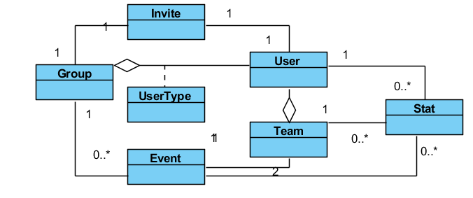
Figure 2 - Logical Structure simplified

3.4.1 User Entity
Data Item | Type | Comment
Name | Text
Email Address | Text
UserName | Text
IsActive | Boolean
Group | Pointer | List
ProfilePicture | Pointer

3.4.2 Group Entity
Data Item | Type | Comment
ID | Integer
Name | Text
User | Pointer | List
Event | Pointer | List

3.4.3 UserType Entity
Data Item | Type | Comment
Group | Pointer
User | Pointer
Accepted | Boolean

3.4.4 Event Entity
Data Item | Type | Comment
ID | Integer
Name | Text
Date | Date
Location | Pointer
Group | Pointer
Team | Pointer | There are 2
Stat | Pointer | List

3.4.5 Team Entity
Data Item | Type | Comment
ID | Integer
Group | Pointer | May be several
Event | Pointer | Used for keyword search
Stat | Pointer | List

3.4.6 Stat Entity
Data Item | Type | Comment
ID | Integer
Type | Text
Value | Text
Group | Pointer | May be several
Event | Pointer | Used for keyword search
User | Pointer | List

3.5 Non-Functional Requirements#TBD
Non-functional requirements may exist for the following attributes. Often these requirements must be achieved at a system-wide level rather than at a unit level. State the requirements in the following sections in measurable terms (e.g., 95% of transaction shall be processed in less than a second, system downtime may not exceed 1 minute per day, > 30 day MTBF value, etc).

3.5.1 Performance#TBD

3.5.2 Reliability#TBD

3.5.3 Availability#TBD

3.5.4 Security#TBD

3.5.5 Maintainability#TBD

3.5.6 Portability#TBD

3.6 Inverse Requirements#TBD
State any *useful* inverse requirements.

3.7 Design Constraints#TBD
Specify design constrains imposed by other standards, company policies, hardware limitation, etc. that will impact this software project.

3.8 Logical Database Requirements#TBD
Will a database be used? If so, what logical requirements exist for data formats, storage capabilities, data retention, data integrity, etc.

3.9 Other Requirements#TBD
Catchall section for any additional requirements.

A. Appendices#TBD
Appendices may be used to provide additional (and hopefully helpful) information. If present, the SRS should explicitly state whether the information contained within an appendix is to be considered as a part of the SRS’s overall set of requirements.

Example Appendices could include (initial) conceptual documents for the software project, marketing materials, minutes of meetings with the customer(s), etc.

A.1 Activity Diagram#TBD

A.2 Class Diagram#TBD

A.3 State Diagram#TBD

A.4 Dependency Matrix#TBD

A.5 Requirements and their attributes#TBD

